*Florida International University*

*School of Computing and Information Sciences*

CIS 4911 - Senior Capstone Project

Software Engineering Focus

Feature Document

User Story #630

**Team Member:**

Andrew Mitchell

**Product Owner(s)**:

Francisco R. Ortega

**Mentor(s)**:

Francisco R. Ortega

...

**Instructor**: Masoud Sadjadi

**User Story** – Create verticle symmetry line

* As a User I would like to Enable a Symmetry line so I can easily draw on both sides of the canvas at once, to make nice symmetric drawings.
* Create Vertical Symmetry Line

Acceptance Criteria

* Be able to draw on the left side of the canvas and it appears at the same height on the right side of the canvas and vice versa.
* Mode must be toggle-able

**Use Case – Toggle Symmetry**

Use Case

Be able to enable a line of symmetry that reflects any drawing done about an axis.

Details:

Actor: User

Pre-conditions:

Multitouch must be running.

Must hit the ‘symmetry line’ button.

Description:

Use case begins when the user enables the symmetry line. A white dotted line will appear on the screen. Any subsequent drawings will be reflected over that axis.

Post-conditions:

All drawings after enabling symmetry should be reflected over the line.

Decision Support:

Frequency: Medium. It is a fun tool that enables much quicker and nicer looking sketches.

Criticality: low. It is an additional ‘fun’ feature to make the program feel more interactive.

Risk: Low. Basic vertical and horizontal symmetry requires very simple algorithms to implement.

Reliability: Highly.

Mean time to Failure –  Almost never. It should only ‘fail’ when the user misses the button to toggle symmetry on or off.

Availability – Available with a keyboard or when the ‘mode buttons’ are open. Added also to the radial menu currently.

Performance:

N/a

Supportability:

Must work with ACER Multitouch.

Leap motion device

Modification History:

Owner: Andrew Mitchell

Initiation date: 3/10/2016

Date last modified: 3/10/2016

**Use Case Diagram**

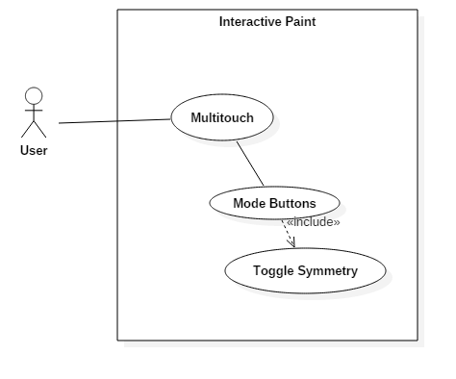

**Sequence Diagram**

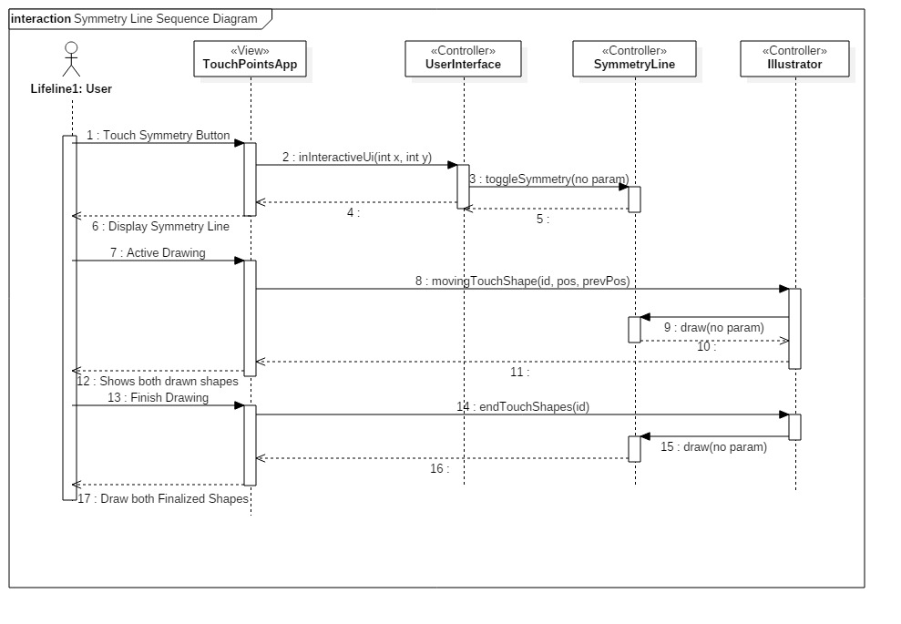

**Class Diagram**

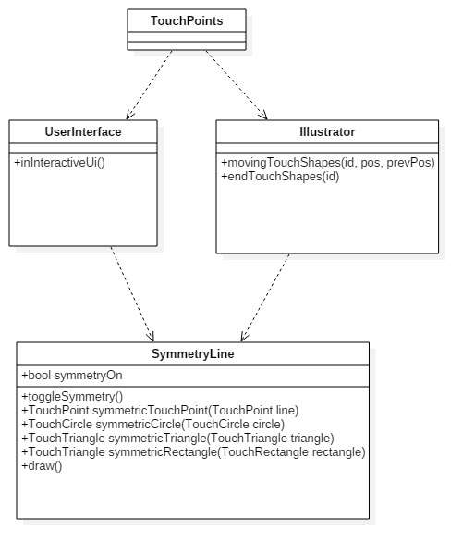

**Unit Test**

Sunny Day Tests

Test Case: Symmetry Line – Draw Line

Test Purpose:

Check to see if the user can successfully draw a line symmetroic to our ‘Symmetry Line’

Test Setup:

1. Tap the symmetry line button
2. Draw a few lines

Test Output:

Drew a line opposite our line of symmetry whenever we drew lines.

Expected Output:

Two lines should be drawn for every line you draw. It should be opposite our line of symmetry.

Rainy Day Tests

Test Case: Symmetry Line – Turn off Symmetry

Test Purpose:

Ensure Symmetric lines don’t draw when it is turned off.

Test Setup:

1. Toggle on symmetry
2. Toggle off symmetry
3. Draw lines

Test Output:

Lines were only drawn where I dragged my finger.

Expected Output:

Only a single line should be drawn per finger input.

**Integration Test**

Currently works with all colors and shapes.

In addition it works properly with Leap Draw,

It works with Multitouch Drawings

It works with Real Sense Drawing.

**User Guide**

Press the button with the dotted line running down the center of it (or ‘s’ if a keyboard is available). A dotted symmetry line will then appear. Draw, and watch it be reflected over an axis!

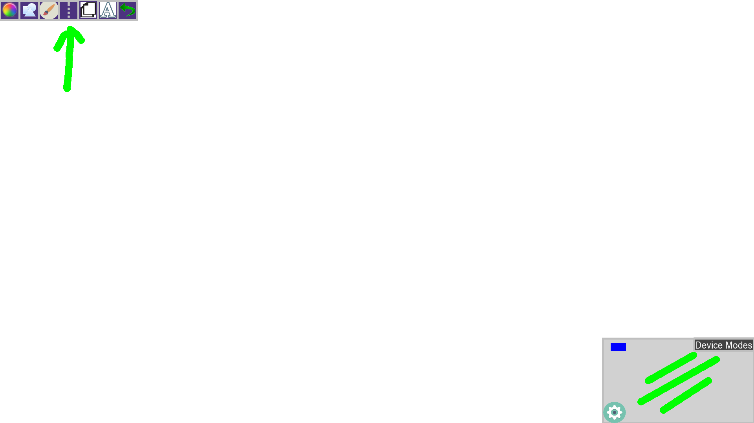

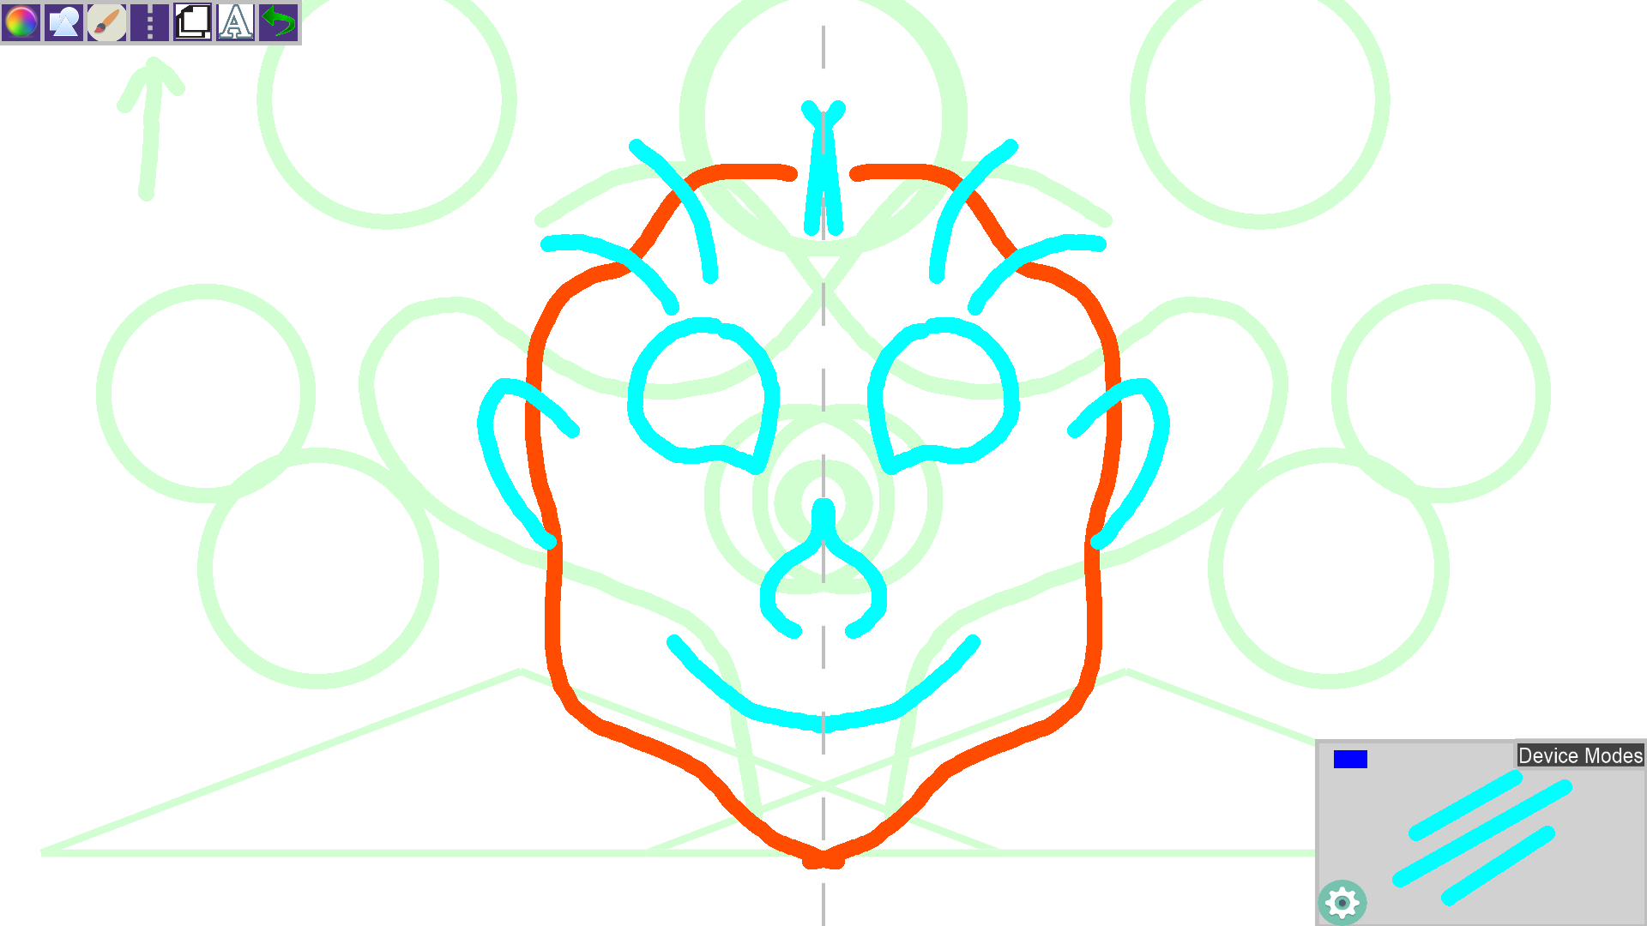

The image below shows the ‘symmetry line’ which is drawn as a dotted line down the middle, as well as the symmetry that was created. We can see examples with multiple shapes as well as line sizes etc.

**Glossary**

Line of Symmetry – A line stored by TouchPointsApp that contains two points which it then makes our line of symmetry. Currently only works with horizontal or vertical lines (3/10/2016).